**IOT & Cyber Security**

~Week 8-9~

IOT

|  |  |
| --- | --- |
| **Project** | Greene Organic Greenhouses |
| **Objectives** | Provide precise control of the greenhouse environment. The IoT system will collect data, analyze that data, and control the greenhouse environment as necessary to ensure that all plants are subjected to optimal growing conditions. |
| **Goals** | Identify the basic IoT infrastructure you will need to include in your IoT solution for:  • Data Collection and Control  • Local Connectivity  • Remote Connectivity  • Remote Data Ingestion, Analytics, and Backend Applications  • Operational Constraints |
| **A) IoT Infrastructure What would be a typical IoT infrastructure setup for our greenhouses?** | * **Sensors:** These are devices that measure various environmental factors in the greenhouse. For example, you might use sensors to measure temperature, humidity, soil moisture, light intensity, etc. * **Actuators:** These are devices that control the greenhouse environment. For example, you might use actuators to open and close windows, turn on irrigation systems, adjust the temperature, etc. * **Gateway:** This is a device that acts as a bridge between the sensor network and the cloud. It receives data from the sensors and sends it to the cloud for storage and analysis. * **Network:** This is the infrastructure that connects the sensors and actuators to the central server. The network might be wired (e.g., Ethernet) or wireless (e.g., Wi-Fi, cellular). * **Central server:** This is a device that collects data from the sensors, processes it, and makes it available to other systems or users. The central server might be a dedicated device (e.g., a computer or a single-board computer like a Raspberry Pi) or a cloud-based service. * **User interface:** This is how users interact with the system. The user interface might be a web-based dashboard, a mobile app, or a combination of both. |
| **B) Constraints What are some constraints we may be dealing with within our greenhouse operation?** | * **Space:** Greenhouses are typically much smaller than outdoor fields, which can limit the number of crops that can be grown at one time. * **Light:** The intensity and duration of natural light can vary greatly depending on location, which can affect the growth of certain crops. * **Temperature:** Maintaining a consistent and optimal temperature range can be challenging, especially in extreme weather conditions. * **Water:** Ensuring that plants have a consistent supply of water is critical and managing water resources can be a significant constraint in some areas. * **Pest and disease control:** Greenhouses can be more vulnerable to pests and diseases than outdoor fields, which can require more careful management and the use of pesticides or other control measures. * **Nutrient management:** Properly balancing the nutrients in the soil or growing medium is essential for healthy plant growth and can be a constraint for greenhouse operators. * **Financial resources:** Greenhouse operations can be expensive to set up and maintain and may require a significant investment of financial resources. |

**Conclusion:**

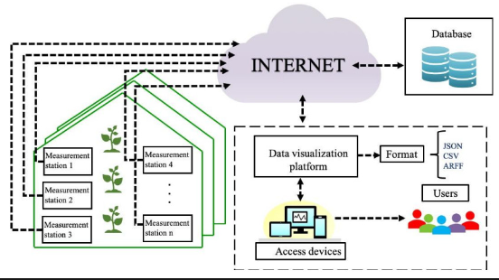

A typical Internet of Things (IoT) infrastructure for a greenhouse might include sensors to monitor temperature, humidity, light intensity, soil moisture, and other relevant environmental variables. These sensors would be connected to a local gateway, which would transmit the sensor data to a cloud-based server for storage and analysis.

The server would run software that processes and analyzes the sensor data to provide insights and trigger alerts, or automated responses as needed. For example, the software might send a notification to a farmer if the temperature in the greenhouse exceeds a certain threshold, or it might automatically adjust the irrigation system to provide more water to a particular section of the greenhouse based on soil moisture levels.

The farmer might also be able to access the sensor data and control the various systems in the greenhouse using a mobile app or web-based dashboard. This would allow them to remotely monitor and manage the greenhouse environment from anywhere with an internet connection.

It's also worth considering incorporating security measures into the IoT infrastructure to protect against unauthorized access or tampering. This might include things like secure communication protocols, authentication, and data encryption.

17330118 – Mustafa Guner